

**PROJECT P2P, PHASE II**

**SUBMITTED TO :**

**SIR BILAL RAUF**

**SUBMITTED BY :**

**ALEENA ZIA**

**MUSARAT SHAMEEM**

**DATE:**

**JUNE 20,2020**

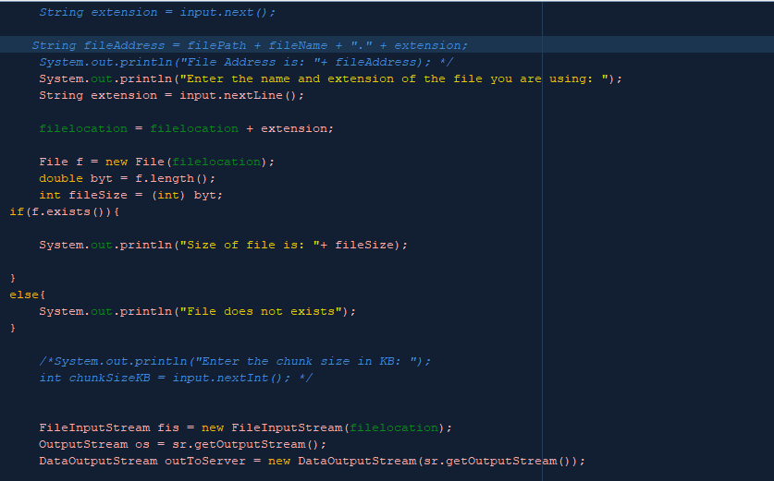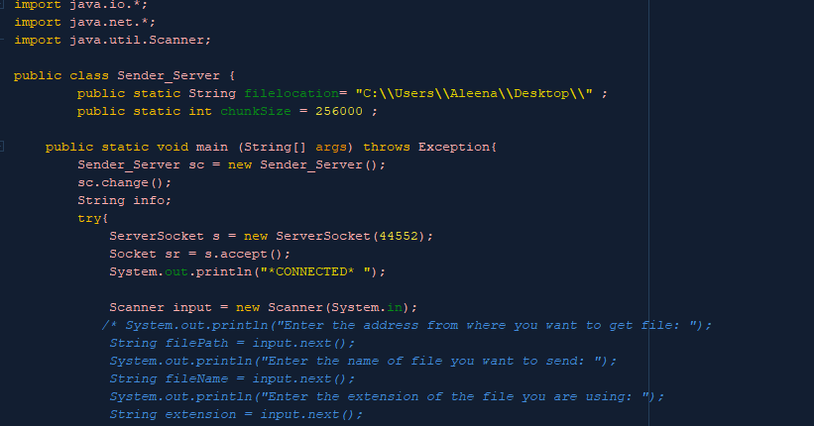**SENDER_SERVER:**

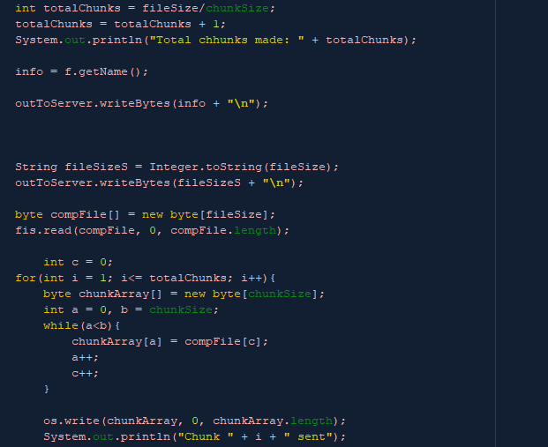

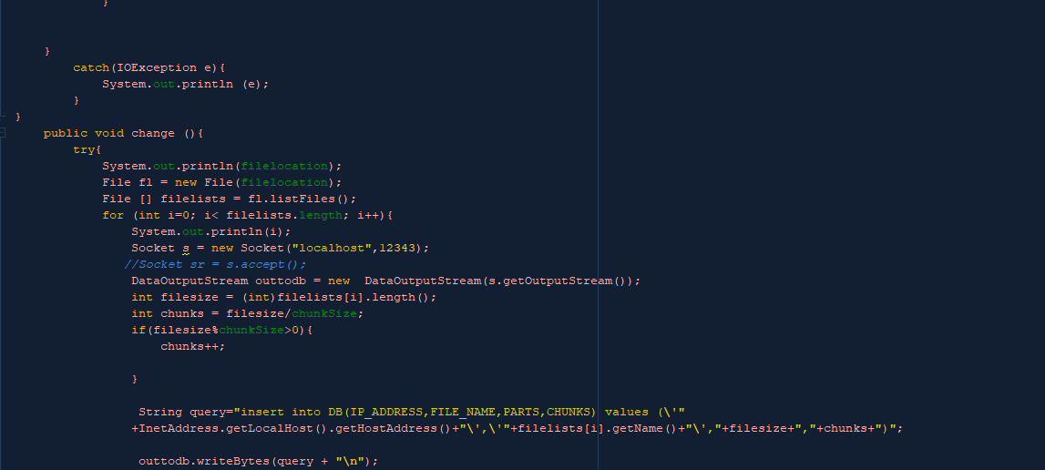

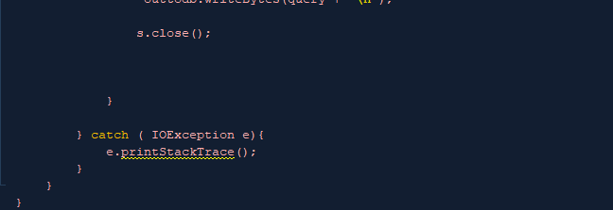

**RECEIVER_CLIENT:**

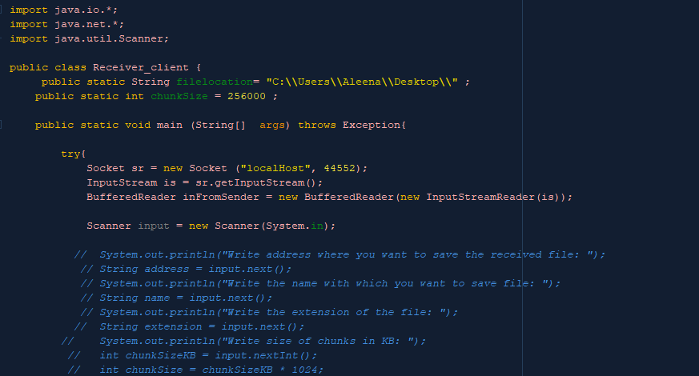

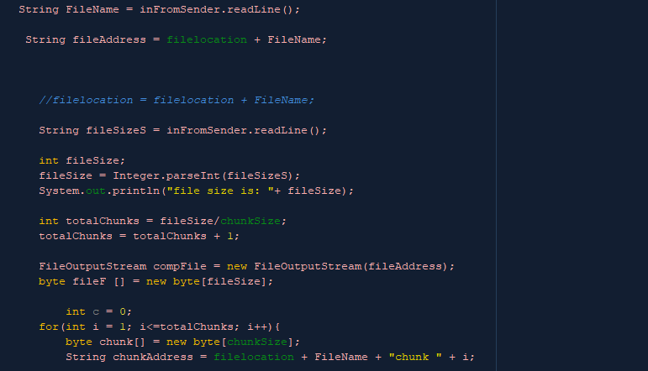

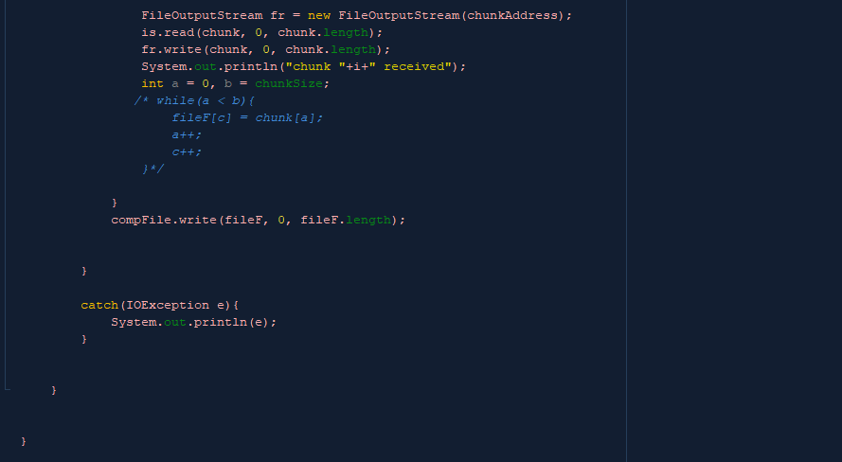

**CONNECTION(For connectivity of shared folder):**

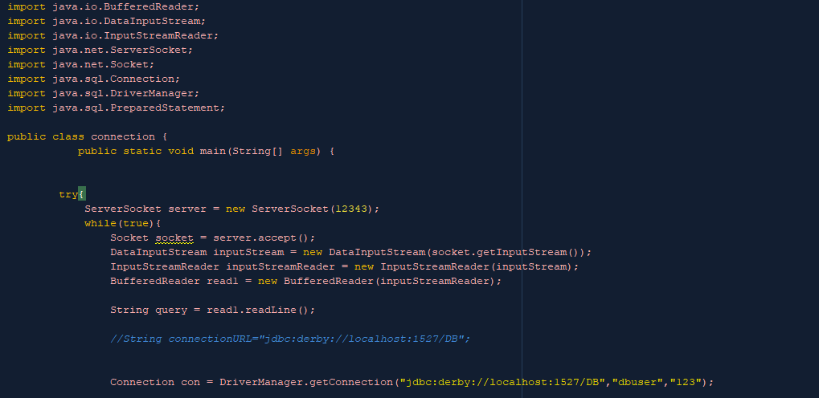

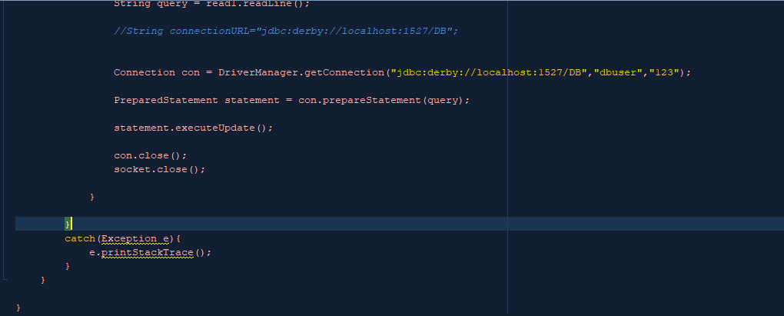

**INSTRUCTIONS:**

1. After phase I, the first step was done to make a connection between database server and the IDE in which the code was written (i.e. NetBeans 8.02).
2. After clicking the **“services”->JB Network ->** . after right clicking on that your create a new database in NetBeans and connect it with the IDE .
3. A query which consist of the tables that is “

IP_ADDRESS

FILE_NAME

PARTS

CHUNKS

There was no primary key in this table, because every time the client connects to the table it is assigned the new IP.

1. The program uses the same program as it was in last phase but in this it connects to the tracker to get access to the files which is the shared folder in server.

The address present in server was written as filelocation= **"C:\\Users\\Aleena\\Desktop\\”;**

1. Following were the credentials of my database created in this :

**DATABSE NAME:** DB

**USERNAME:** dbuser

**PASSWORD:** 123

**Host:** Localhost

**f.** For connection another class named connection was made

String query = read1.readLine();

**//String connectionURL="jdbc:derby://localhost:1527/DB"; //**

**Connection con = DriverManager.getConnection("jdbc:derby://localhost:1527/DB","dbuser","123");**

**PreparedStatement statement = con.prepareStatement(query);**

**statement.executeUpdate();**

**con.close();**

**socket.close();**

**g.** After connecting and executing the following table was displayed. This is the table whose address was displayed

